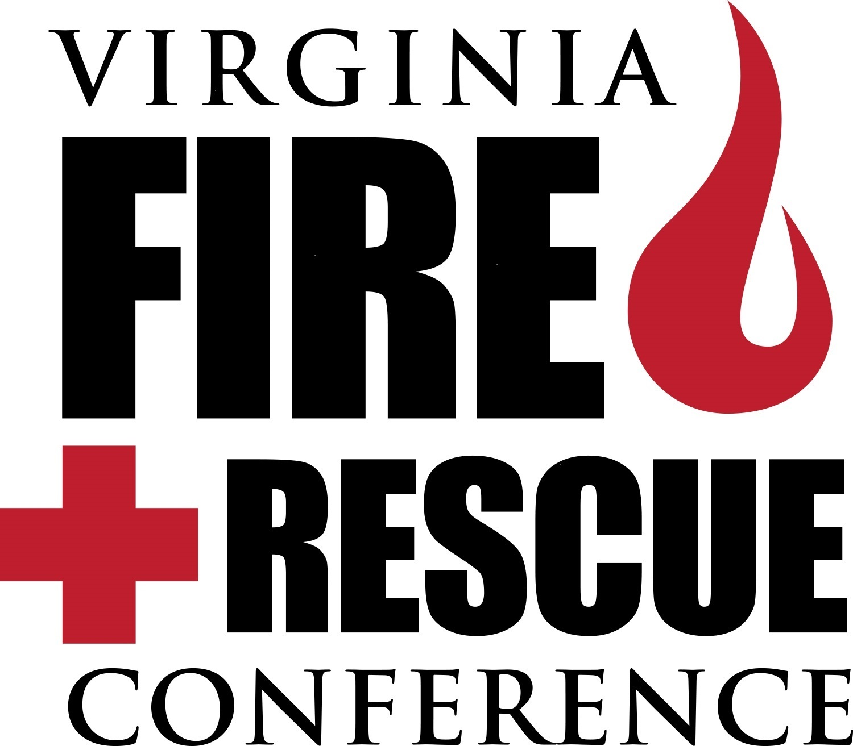

2018 SPONSORSHIP PACKAGES

CHIEF - $15,000
- Designated as Sponsor for Saturday Lunch
- Sponsor of the Celebration Dinner Reception
- Company Profile w/link on VFCA web (75 words+link)
- Company Logo Displayed on Entry Arch at Conference
- Invitation for 6 people to attend Celebration Dinner
- One year free banner ad on VFCA website ($1200 value)
- Discount on Advertisement in CC – 10%
- Recognition as a Chief Sponsor on the VFCA website
- Banner posted over Vendor Space as Chief Sponsor
- Recognition as Chief Level Sponsor on Conference app
- VFCA will send out up to 4 special notifications to members
- Listed on a Sponsor page in April Edition of Commonwealth Chief
- Priority Exhibit Floor Space Selection for following year at VFR Conference

DEPUTY CHIEF - $10,000
- Designated as Sponsor of the Friday Lunch
- Company Profile w/link on VFCA web (50 words+link)
- Company Logo displayed on Entry Arch at Conference
- Invitation for 4 people to attend Celebration Dinner
- Discount of 10% for VFCA Web Advertising
- Discount on Advertisement in CC - 5%
- Recognition as a Deputy Chief Sponsor on VFCA Website
- Banner posted over Vendor Space as Deputy Chief Sponsor
- Recognition as Chief Level Sponsor on Conference app
- VFCA will send out up to 3 special notifications to members
- Listed on a Sponsor page in April Edition of Commonwealth Chief
- Priority Exhibit Floor Space Selection for following year at VFR Conference

ASSISTANT CHIEF - $5,000
- Designated as Sponsor for Casino Night
- Company Profile w/link on VFCA web (25 words+link)
- Invitation for 2 people to attend Celebration Dinner
- Discount of 10% for VFCA Web Advertising
- Recognition on VFCA Web as Assistant Chief Sponsor
- Recognition as Assistant Chief Level Sponsor on Conference app***
- VFCA will send out up to 2 special notifications to members
- Listed on a Sponsor page in April Edition of Commonwealth Chief
- Priority Exhibit Floor Space Selection for following year at VFR Conference

BATTALION CHIEF - $2,500
- Designated as Sponsor of Thursday Hospitality Room
- Company Logo and Link of Company on VFCA Website
- Invitation for 1 person to attend Celebration Dinner
- Recognition on VFCA Web as Battalion Chief Sponsor
- Discount of 5% for VFCA Web Advertising
- Listed on a Sponsor page in April Edition of Commonwealth Chief

COMPANY OFFICER - $1,000
- Designation as Sponsor for Refreshment Breaks
- Recognition as Company Officer Sponsor on VFCA Website
- Listed on a Sponsor page in April Edition of Commonwealth Chief

The benefits outlined are as related to the 2017 conference year.
Additional a-la-cart sponsorships are also available – see 2nd page.

OTHER SPONSOR OPPORTUNITIES

CONFERENCE BAGS - $2500
- Your company logo imprinted on the bag that will be given to all conference attendees.

CONFERENCE BAG INSERT - $500
- We will insert a one-page flyer from your company in our conference materials.
1000 copies to be provided by sponsor and must be delivered to VFCA on-site
(convention center) by 2/17/17.

TRI-FOLD PROGRAM - $2500 (Committed)
- Exclusive sponsorship of the pocket program that is given to all attendees.

